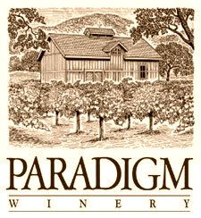

**2012 Cabernet Sauvignon**

*Release date: October 1st, 2015*

*Appellation: Oakville, Napa Valley*

*Vineyard: All estate from Paradigm Vineyards*

*Blend: 96% Cabernet Sauvignon, 3% Merlot, 1% Petit Verdot*

*Alcohol: 14.6%*

*Winemaker: Heidi Peterson Barrett*

*Production: 4,267 cases*

My first comment tasting this wine is “wow!” It’s delicious; our flagship wine at Paradigm and it delivers. Dense, deep, ripe aromas of black berry and black cherry-like fruit is layered with caramel and toastiness from a nice mix of French Oak barrels. Flavors coat the palate with matching notes in a classic Cabernet Sauvignon presentation. One of our best Cabs to date!