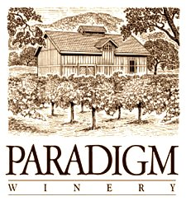

2015 Rose’ of Merlot

Release date: February 14th, 2016

Appellation: Oakville

Vineyard: All estate from Paradigm Vineyards

Blend: 100% Merlot, Single Vineyard

Winemaker: Heidi Barrett

Production: 615 cases

The 2015 Rose’ is a brilliant salmon pink wine with clean fresh aromatics of strawberry and delicate rose petals. Across the palate the wine is refreshing, bright, and crisp. Our Rose’ is dry, lending itself perfectly for many food pairings. It’s fruity with nice acidity and persistent clean flavors.