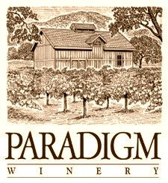

**2012 Merlot**

*Release date: September 1st, 2015*

*Appellation: Oakville, Napa Valley*

*Vineyard: All estate from Paradigm Vineyards*

*Blend: 96% Merlot, 3% Cabernet Sauvignon, 1% Petit Verdot*

*Alcohol:14.6%*

*Winemaker: Heidi Peterson Barrett*

*Production: 791 cases*

The 2012 Merlot is medium dark ruby in color with clean aromatics of ripe plums and cherries layered with light touches of spice and sweet French Oak notes. Truly a yummy Merlot across the mouth it is soft and silky, truly a seamless wine. There is nice purity of flavors here with an exciting flavor profile, lively but with a nice finish. I love the mouth feel and ripeness we were able to get from our vineyard in 2012. This is an easy wine to love.