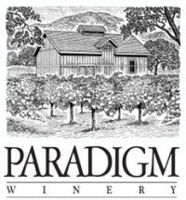

***2011 Cabernet Sauvignon***

Release date: March 1, 2015

Appellation: Oakville

Vineyard: All estate from Paradigm Vineyards

Blend: 90% Cabernet Sauvignon, 6% Merlot, 2% Cabernet Franc, 2% Petit Verdot

Winemaker: Heidi Peterson Barrett

Production: 4,000 cases

Winemaker notes:

Our 2011 Cabernet Sauvignon is a blend of Cabernet Sauvignon, Merlot, Cabernet Franc, and Petit Verdot from our Oakville estate. Deep ruby red color with aromas of plum and black cherry, some spice, hints of cedar, and a light touch of French Oak, this wine is smooth as silk and ready to drink. Flavors match the aromas, balance is refined, and the finish is soft and lush. Tasty now and over the next 10-12 years, but no need to wait.

*Heidi Peterson Barrett, Winemaker*