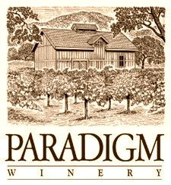

**2012 Cabernet Franc**

*Release Date: September 1st, 2015*

*Appellation: Oakville, Napa Valley*

*Vineyard: All estate from Paradigm Vineyards*

*Blend: 76% Cabernet Franc, 13% Cabernet Sauvignon, 8% Merlot, 3% Petit Verdot*

*Alcohol: 14.8%*

*Winemaker: Heidi Peterson Barrett*

*Production: 919 cases*

This Cabernet Franc is black cherry red in color with aromas of blueberry jam and white pepper spiciness. With wonderful ripeness in 2012 we were able to make one of our best Cabernet Francs. The wine is very lush across the palate with a silky softness and sweet impression of ripe blueberry fruit. Tannins are very moderate with a nice light texture in the mid palate. This is an easy drinking Cabernet Franc, rich and complete and very enjoyable.